Spring Boot:
Spring boot is a java framework used to create standalone web applications and microservices applications with spring framework
Advantages of Spring Boot over spring: Spring provides loosely coupled applications. Spring Boot is designed to make Spring Framework easy to use.
- Fast and Easy Development
- Have Embedded Tomcat Servers
- Create standalone applications and Production ready app
- Reduced XML Configuration and code for configs
- Auto Configuration
- Dependency Management
- Actuators and Manage Environment
Spring over SpringBoot:
- Dependency management resolution/Avoid version conflict
- Avoid addition configuration (No boiler plate code)
- Embedded Tomcat (No need to convert into war and deploy in server)
- Production ready features like actuators
To exclude a class from autoconfiguration:
@EnableAutoConfiguration(exclude=<Class to be excluded>.class)

Run Springboot application without embedded server - spring.main.web-application-type=none
Change Spring application port: server.port=8081
Exclude a dependency from pom: exclusion tag
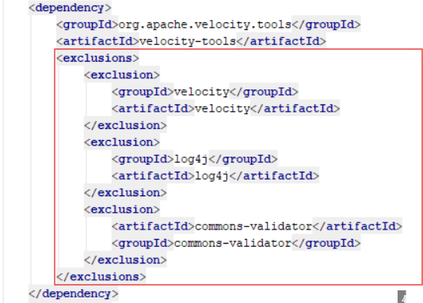
Internal Working of Spring Boot run() method:
- Load Env properties and create Application Context
- Register Bean into Context
- Kickup Embedded Tomcat Container to war/jar

Embedded Tomcat Settings:
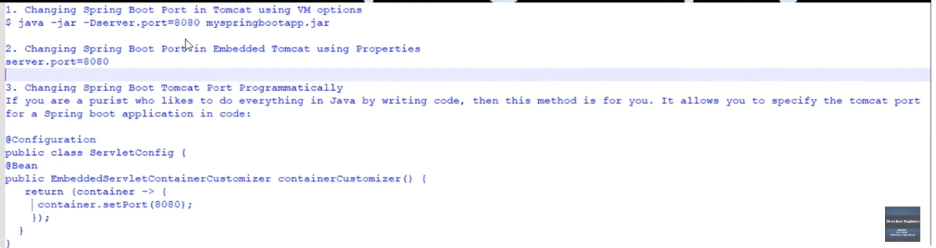
SpringBootStarter: spring-boot-starter is the Core starter and provides functionalities including auto-configuration support, logging and YAML.It defines spring-boot-dependencies as the parent pom.xml
Springboot Starter dependency: Provides the basic set of dependencies to run a spring boot application
Spring Boot Starter Parent helps us with managing dependency versions, the java version used by project and the default configuration for plug-ins, as we don't have to specify a lot of things manually. Manages overall project configuration, dependency and plugin versions.It is a club of related dependencies that is used to create a standalone springboot application.
Spring Boot Actuator:
Spring Boot Actuator is a module that provides production-ready features to monitor and manage your Spring Boot application. It offers and exposes various endpoints and metrics that can be used for monitoring, health checks, auditing, and managing your running application. The actuator exposes these features via RESTful endpoints or JMX (Java Management Extensions) beans.
Add spring-boot-starter-actuator to your pom.xml File and management.endpoints.web.exposure.include=* to application properties to expose every endpoint in actuator. Ex: /health, /env…
Spring Boot Dev Tools:
Development Tools is a spring boot module that improve the development time of the Springboot Application. It picks the code changes and restart the application. It provides Live Reload.
Add spring-boot-devtools dependency in your pom.xml file.
Spring Profiles:
Spring Profiles are used to segregate the properties with respect to the environment. Used to define specific property files in form of application-dev.properties or application-dev.yml. It automatically loads the profiles the application depends on the profile environment required.
Create new profile for external configuration: application.<profilename>.extn
To Activate profiles in spring:
- java -jar <jarname> --spring.profiles.active=test
- Selecting the beans/class by profile @Profile(“test”,”prod”) at bean/class level and use @Profile(“!test”) to ignore the profile.
- Run Configurations in STS – profiles or arguments or environment pass the spring.profiles.active=test
Ways to Load external properties in application:
Load Properties from External Config Default Config: @Value("${<property-variable>}")
Load Properties from External Config Custom Multiple Config: @PropertySource({"classpath:/<custom-path1>","classpath:/<custom-path2>"})
Load Properties by Autowiring the Environment:
@Autowired
private Environment env;
String propertyname = env.getProperty(<property-variable>);
Load Properties by @ConfigurationProperties(Used bind config properties to java object)
Load External Properties file in spring: spring.config.import=<path>
https://mkyong.com/spring-boot/how-to-access-values-from-application-properties-in-spring-boot
Both application.properties and application.yml will be loaded while starting the application but properties takes precedence.
Yaml | Properties
Stores data in hierarchal format | Stores data in sequential format
Supports Key-pair Values | Supports Key-pair, map, list and scalar types
Java | Java, python, etc..
Need to create each file for profiles | Can use multiple profiles in a same file

PUT | PATCH
Method used to modify the resource where the client sends the entire data to update. | Method used to modify the resource where the client sends the partial data that to be updated without modifying the entire data.
Internal Working of JPA:
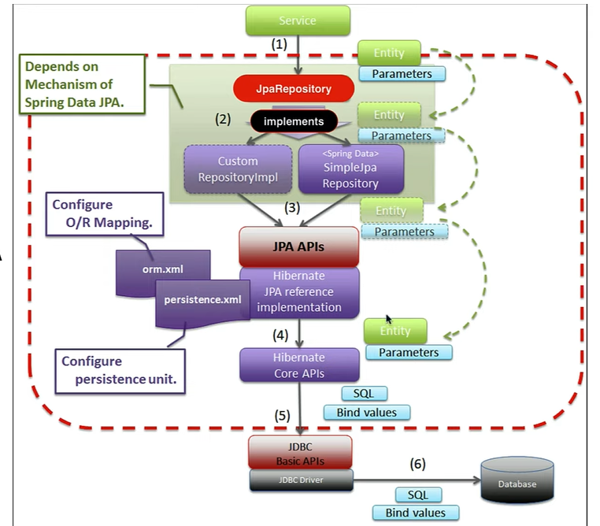
HTTP Methods:
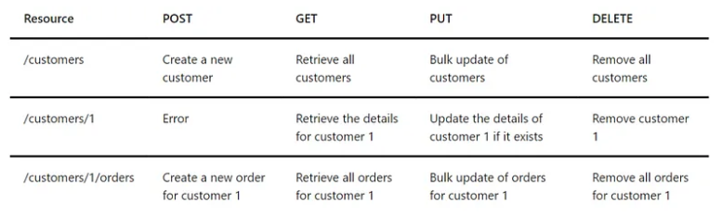
Configure Global Exception Handler:
@ControllerAdvice in class level
@ExceptionHandler(values= { ValidationException, ResourceNotFoundException }) in method level.
Interactions Between Microservices:
Synchronous:
- Feign Client
- Rest Template
- WebClient
Asynchronours:
- Message Brokers
Spring Request Interceptor: Spring Boot Interceptor is an additional component that will intercept every request and response dispatch and perform some operations on it.
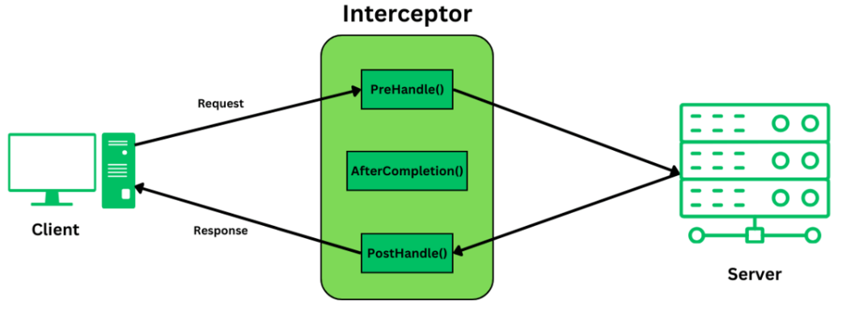
We can intercept the request before reaching the controller, and execute code before and after for logging, authentication and modify the request/response.
Interceptor Implementation: https://www.geeksforgeeks.org/spring-boot-interceptor/
Ex: Datazap we used Request Interceptor to get the Authentication details and In Bulk Contribution API’s we have intercepted the requests and validated the API Token.
Disadvantages of Microservices from Personal experience:
- Complicated and expensive then monolith architecture (Infrastructure and resources)
- Security, Network latency and Load balancing.
Considering each microservices has an individual data source, I have a requirement to join data from two data sources, how to implement this?
https://www.geeksforgeeks.org/how-do-we-join-the-data-among-different-microservices/
- API Calls (Aggregate API req or response)
- CQRS
- Data Duplication and Sync
- Event Sourcing
Loggers:
- SLF4J - The Simple Logging Facade for Java (SLF4J) serves as a simple facade or abstraction1 for various logging frameworks (e.g. java.util.logging, logback, log4j) allowing the end user to plug in the desired logging framework at deployment time.It is not itself a logging library, but a generic interface to one of many logging libraries.
- Log4j 1.2 - Welcome to Apache log4j, a logging library for Java.
- Logback - Logback is intended as a successor to the popular log4j project, picking up where log4j leaves off.
- Log4j 2 - Apache Log4j 2 is an upgrade to Log4j that provides significant improvements over its predecessor, Log4j 1.x, and provides many of the improvements available in Logback while fixing some inherent problems in Logback's architecture.
Transaction: A transaction is a series of actions that must be executed successfully. If one of operations fails, the entire steps must be rolled back to leave the application to the previous stable state.
Transaction Management:
@Transactional is used to manage transactions in Springboot. @Transactional can be applied in class and method level so the transactions to the database is performed with the annotated class or method. If any exceptions occur every database operation under the @Transactional will be rolled back. Used to achieve ACID properties while doing transaction.
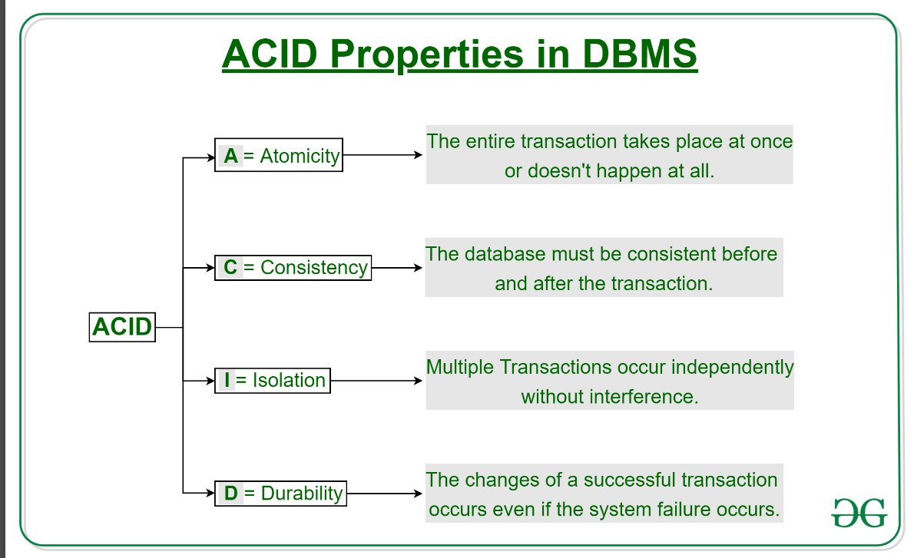
To enable transactional management, you need to annotate @EnableTransactionManagement to main class and @Transactional to a class or method.
@Transactional will create a new transaction and if we have an existing transaction the method annotated with @Transactional will execute under the existing transaction of default scope(Required). Only Public methods should be annotated with @Transactional.
Properties of Transaction:
timeout: Maximum time that a transaction should take to complete or rollback
rollbackFor: used to specify the exceptions that should cause a transaction to roll back when particular exception occurs
notRollbackFor: used to specify the exceptions that should not transaction to roll back when particular exception occurs
readOnly - Used to indicate that a transaction should be read-only
Propagation Levels:
REQUIRED: Supports current transaction and create one if none exists.
REQUIRED.NEW: Creates new transaction and suspends the current transaction if one exists.
SUPPORTS: Supports current transaction and execute non transactionally if none exists.
MANDATORY: Supports current transaction and throw exception if none exists.
NOT_SUPPORTED: Executes non-transactionally suspends the current transaction if exists.
NEVER: Executes non-transactionally throw exception if transaction exists.
NESTED: Marks a save point if transaction exists and rollback to the save point if exception occurs in between the transaction.
Isolation: Isolation prevents zero or more concurrency side effects on a transaction
Dirty read: Read the uncommitted change of a concurrent transaction
Nonrepeatable read: Get different value on re-read of a row if a concurrent transaction updates the same row and commits
Phantom read: Get different rows after re-execution of a range query if another transaction adds or removes some rows in the range and commits
Isolation Levels:
DEFAULT: Default level of database when a new transaction is created
READ_UNCOMMITTED: A transaction with this isolation reads uncommitted data of other concurrent transactions. Also, both non-repeatable and phantom reads can happen. Thus, we can get a different result on re-read of a row or re-execution of a range query. Postgres and Oracle does not support READ_UNCOMMITTED isolation and falls back to READ_COMMITED
READ_COMMITTED: The second level of isolation, READ_COMMITTED, prevents dirty reads and other concurrency issues will happen. But results may change while re-querying. Supported by all Postgres, SQL and Oracle and default isolation level of the DB.
REPEATABLE_READ: The third level of isolation, REPEATABLE_READ, prevents dirty, and non-repeatable reads. So we are not affected by uncommitted changes in concurrent transactions but lost update will occur when two or more concurrent transactions read and update the same row.
SERIALIZABLE: SERIALIZABLE is the highest level of isolation. It prevents all mentioned concurrency side effects, but can lead to the lowest concurrent access rate because it executes concurrent calls sequentially.
Pessimistic locking vs Optimistic locking:
Optimistic locking is used when data conflicts are rare, using a version column to prevent concurrent updates unless the data is unchanged. Pessimistic locking assumes conflicts are likely, locking data for the duration of a transaction to prevent access by other transactions.
Distributed Transactions: Transactions that span over multiple microservices over the network. It is a concept of maintaining Transaction when multiple service calls are involved.
To handle concurrent request and to achieve distributed transactions we can use:
Saga Pattern:
Choreography-Based Saga: Each service involved in the transaction performs its local transaction and then publishes an event. Other services listen to this event and perform subsequent transactions.
Orchestration-Based Saga: A central coordinator (orchestrator) manages the transaction by invoking each service and handling the response.
Two-Phase Commit (2PC): Ensures atomicity across multiple services but can be complex and may suffer from performance issues and blocking.
Microservices Design Patters:
Microservice design patterns are essential for designing robust, scalable, and maintainable microservices architectures. Here are some common design patterns used in microservices:
1. Decomposition Patterns
Service Decomposition by Business Capability: Decompose services based on business capabilities, ensuring each service aligns with a specific business function.
Service Decomposition by Subdomain: Decompose services based on subdomains within the domain-driven design (DDD) context.
2. Database Patterns
Database per Service: Each microservice has its own database to ensure loose coupling and independent scalability.
Shared Database: Multiple services share a single database. This pattern is less common due to potential coupling issues.
3. Integration Patterns
API Gateway: A single entry point for all client requests, routing them to appropriate services. It can also handle cross-cutting concerns like authentication and rate limiting.
Aggregator: A service that invokes multiple microservices and aggregates the results into a single response.
Chained or Orchestration: Services call each other in a predefined sequence (orchestrated by a central service) to complete a business process.
4. Communication Patterns
Synchronous Communication (HTTP/REST): Services communicate using synchronous protocols like HTTP/REST. Rest Template, Feign Client and Web Client.
Asynchronous Communication (Messaging): Services communicate using asynchronous messaging protocols like RabbitMQ, Apache Kafka, or AWS SQS.
5. Data Consistency Patterns
Event Sourcing: Maintain an immutable sequence of events to track changes in the application state.
CQRS (Command Query Responsibility Segregation): Separate the read and write operations to optimize performance and scalability.
Saga Pattern: Manage distributed transactions using a sequence of local transactions with compensating actions for failure.
6. Resilience Patterns
Circuit Breaker: Prevent cascading failures by stopping requests to a failing service until it recovers.
Bulkhead: Isolate services to prevent failures in one service from affecting others.
Retry: Automatically retry failed requests with configurable backoff strategies.
7. Security Patterns
Access Token: Use JWT (JSON Web Tokens) for stateless authentication and authorization.
API Gateway Security: Implement security at the API Gateway level to manage authentication and authorization for all incoming requests.
8. Observability Patterns
Centralized Logging: Aggregate logs from all services into a centralized logging system like ELK Stack or Splunk.
Distributed Tracing: Trace requests across services to understand the flow and diagnose performance issues using tools like Jaeger or Zipkin.
Health Check: Implement health checks to monitor the status of each service and ensure they are running correctly.
9. Deployment Patterns
Blue-Green Deployment: Deploy a new version of the application in parallel with the old one and switch traffic to the new version once it's ready.
Canary Deployment: Gradually roll out the new version to a small subset of users before a full rollout.
10. Service Discovery Patterns
Client-Side Discovery: Clients query a service registry to find the service instance they need to connect to.
Server-Side Discovery: The API Gateway or a load balancer queries the service registry and routes the request to the appropriate service instance.
Implementing these patterns helps create a resilient, scalable, and maintainable microservices architecture. Each pattern addresses specific challenges and provides a structured approach to solving them.
Explain Eureka in Microservices.
Eureka, created by Netflix, is an important component in microservices architecture. It's a service registry, a centralized repository where microservices register themselves so other services can easily discover and communicate with them.
Here's how Eureka fits into the microservices ecosystem:
Service Registration: When a new microservice starts, it registers itself with the Eureka server. This allows other microservices to find it.
Service Discovery: When a microservice needs to communicate with another, it queries the Eureka server to find the target service's instance.
Load Balancing: Eureka can help distribute traffic evenly across multiple instances of a microservice, enhancing reliability and performance.
Health Monitoring: Eureka periodically checks the health of registered services, removing any that become unresponsive from the registry.
What is circuit breaker pattern?
The Circuit Breaker pattern is a popular design pattern used in Microservices Architecture, that falls under the Sustainable Design Patterns category. In Microservices architecture, a service usually calls other services to retrieve data, and there is the chance that the downstream service may be down. It may be cause by slow network connection, timeouts, or temporal unavailability. Therefore, retrying calls can solve the issue. However, if there is a severe issue on a particular microservice, then it will be unavailable for a longer time. In such case, the request will be continuously sent to that service, since the client doesn’t have any knowledge about a particular service being down. As a result, the network resources will be exhausted with low performance and bad user experience. Also, the failure of one service might lead to Cascading failures throughout the application.
Therefore, you can use the Circuit Breaker Design Pattern to overcome this problem. With the help of this pattern, the client will invoke a remote service through a proxy. This proxy will basically behave as an electrical circuit breaker. So, when the number of failures crosses the threshold number, the circuit breaker trips for a particular time period. Then, all the attempts to invoke the remote service will fail within this timeout period. After the timeout expires, the circuit breaker allows a limited number of test requests to pass through it. If those requests succeed, the circuit breaker resumes back to the normal operation. Otherwise, if there is a failure, the timeout period begins again.
How to configure eureka server?
Eureka Server is an application that holds the information about all client-service applications. Every Micro service will register into the Eureka server and Eureka server knows all the client applications running on each port and IP address. Eureka Server is also known as Discovery server/ Service Registry. Eureka Server comes with the bundle of Spring Cloud
Dependency: Spring Cloud Netflix Eureka Server
Annotation in main class: @EnableEurekaServer
Application Config Changes:
spring.application.name=EurekaServerName
server.port=8671
eureka.client.fetch-registry=false
eureka.client.register-with-eureka=false
What is api gateway with proper explanation?
The API Gateway is a server. It is a single-entry point into a system. API Gateway encapsulates the internal system architecture. It provides an API that is tailored to each client. It also has other responsibilities such as authentication, monitoring, load balancing, caching, request shaping and management, and static response handling.
Example: Netflix Zuul
Two configs A and B in spring boot, how to use Config B beans inside Config A? Create two Configs A and B then Inject Config B bean into Config A by Autowiring using constructor or Field injection
Two beans are there in my config, I want BeanB should get initialized before Bean A, how to achieve? The @DependsOn("beanB") annotation on BeanA ensures that BeanB is initialized before BeanA
Which feature in cloud do you think is best according to you, why?
The ability to easily scale up or down computing resources based on demand, allowing for cost-effective utilization and flexibility for businesses of all sizes.
Explain various types of Spring Bean Auto wiring:
Autowiring in the Spring framework can inject dependencies automatically. The Spring container detects those dependencies specified in the configuration file and the relationship between the beans. It can be done using @Autowired also.
XML Configuration:
- ‘no’ means the autowiring is OFF and default mode in spring.
- ‘byName’ requires that the name of the property and bean must be the same. It invokes the setter method internally for autowiring.
- ‘byType’ permits a property to be autowired if there is exactly one bean of the property type in the container.
- ‘constructor’ is equivalent to byType but operates to constructor arguments.
- ‘Autodetect’ tries to autowire via the constructor mode and if it fails, it uses the byType mode for autowiring and has been deprecated after Spring 3.0
@Autowired Annotation: Uses autowiring byType
- Field injection: Injects dependencies directly into fields using annotations.
- Constructor injection: Provides dependencies through a class constructor and used when dependencies are mandatory and must be provided when the object is created.
- Setter injection: Provides dependencies through setter methods and used when dependencies are optional or can change.

Logging mechanism for microservices:
A logging mechanism for microservices typically involves using a centralized log aggregation system to collect logs from multiple independent services, incorporating unique correlation IDs to track requests across services, and structuring log data in a consistent format with relevant context like service name, timestamps, and request IDs, enabling easier analysis and troubleshooting within a distributed system.
Key elements of a microservices logging mechanism:
Structured Logging: Utilizing a standardized format like JSON to store log data, allowing for easier parsing and filtering.
Correlation IDs: Unique identifiers assigned to each request, enabling tracing a single transaction across multiple services.
Log Levels: Using predefined levels like DEBUG, INFO, WARN, ERROR, and FATAL to categorize log severity and filter based on importance.
Contextual Data: Including relevant information like service name, user ID, request ID, and timestamps in each log entry.
Centralized Log Management: A dedicated platform to collect, store, and analyze logs from all microservices in one place
Distributed Tracing: Implement distributed tracing to trace requests across microservices and understand the flow of requests. Tools like Jaeger, Zipkin, and AWS X-Ray provide detailed insights into request flows and help identify performance bottlenecks.
Deployment of microservices:
- Single Machine, Multiple Processes - Run multiple microservices as separate processes on a single machine.
- Multiple Machines, Multiple Processes - Distribute microservices across multiple servers to improve scalability and availability.
- Containers-Package microservices in containers (e.g., Docker) to simplify deployment and management.
- Orchestrators (e.g., Kubernetes, Nomad)-Use orchestration tools to manage and scale containers across multiple machines.
- Serverless-Deploy microservices as functions in a serverless environment (e.g., AWS Lambda, Azure Functions).
How to secure communication between multiple microservices calls? Authentication and Authorization(JWT and Oauth2), API Gateway and SSO.
REST (Representational State Transfer) API operates based on a client-server architecture where a client requests data from a server by identifying resources with unique URLs, using standard HTTP methods like GET, POST, PUT, and DELETE to manipulate those resources, all while maintaining a stateless interaction, meaning each request contains all necessary information and doesn't rely on previous interactions with the server; this allows for scalability and flexibility in application development

Internal Working of Rest:
- Client Request: The client sends an HTTP request to a specific resource URL on the server, specifying the desired action using an HTTP method (GET, POST, PUT, DELETE).
- Server Processing: The server receives the request, identifies the resource based on the URL, and performs the requested action on the data.
- Response: The server sends back a response to the client, which includes the requested data in a format like JSON or XML, along with status codes indicating the success or failure of the operation.
Explain what issue Service discovery solves:
- Dynamic service location (Changes in port and url can be dynamically identified)
- Load Balancing
- Fault Tolerance and Resilience
- Service Registry and Discovery Mechanisms and Scalability
Java object to json – The ObjectMapper class is part of the Jackson library, which is a popular library for processing JSON data in Java. It provides a simple and powerful way to convert Java objects to JSON and vice versa. It is done using the Jackson Library. Ex: @JsonProperty, @JsonIgnore
In how many ways I can validate data of a student where first name and last name should not be blank (or) validate or sanitize the request input – (Custom Validation)?
- Bean Validation (JSR 380): Add spring-boot-starter-validation or hibernate-validator dependency and Use annotations like @NotBlank, @NotNull, @Min, @Max, @Size etc
- Custom Validator: Create custom annotations and validators.(Account API Request Validation)
- Validation in Controller Layer: Perform manual validation in the controller.
How to stop bean getting initializing in spring boot?
- Conditional Beans: Use @Conditional annotations to control initialization based on custom conditions.
- Profile-Specific Beans: Use @Profile to initialize beans only for specific profiles.
- Exclude from Component Scan: Exclude specific packages or classes from component scanning.
- Exclude Auto-Configuration Classes: Use the exclude attribute to exclude specific auto-configuration classes.
- Conditionally Creating Beans Based on Environment or Properties: Use @ConditionalOnProperty to initialize beans based on application properties.
How to pass header parameter as method input spring boot:
To pass a header parameter as a method input in a Spring Boot application, you can use the @RequestHeader annotation in your controller method. You can use it as optional and some default values also like @RequestParam annotation
To send custom headers to your responses, you can use HttpHeaders class, which provides methods to set and manipulate HTTP headers and send as headers in ResponseEntity.
How exceptions are handled in microservices – Using Global Exception Handler with HTTP codes and customized error response – Bulk Contribution API’s
How to identify the failed services in microservices - Open Tracing using zipkin or jaeger.
Jaeger Implementation in SB 3.x - https://www.youtube.com/watch?v=jfbUwZwzC98
HTTP Methods:
- GET: Retrieves data on a server
- DELETE: Removes a resource
- POST: Creates a resource or appends data to a resource
- PUT: Create a new resource or replace a resource with an updated version
- PATCH: Updates an existing resource, usually by making partial changes
@Requestbody is not recommended to use in Get HTTP method. Update operation is not recommended to use Post Http method
How will you implement put rest docs says put can also save data when data is not found? To implement a PUT request in Spring Boot that can create a new record if the data is not found, you can leverage Spring Data JPA's save() method within your controller, which automatically handles the creation or update based on whether the entity with the provided ID exists in the database; if not found, it will create a new entry with that ID
Delete Mapping not a frequent implementation for prod apps, explained why? DELETE endpoints might not be frequently implemented in production applications due to concerns around compliance, auditing, accidental deletion, dependency management, and business logic, alternative approaches like soft deletion, archiving, and logical deletion provide ways to manage data effectively without permanently removing it.
Content Negotiation (JSON/XML) in rest endpoint? Use produces and consumes parameter with the media types need to be supported. And add “jackson-dataformat-xml” dependency for xml transformation.
spring.mvc.contentnegotiation.favor-path-extension=true
spring.mvc.contentnegotiation.favor-parameter=true
spring.mvc.contentnegotiation.defaultContentType=application/xml
HTTP status codes are standardized response codes given by web servers on the Internet. These codes help identify the status of the requested operation. They are divided into five categories:
1xx: Informational
- 100 Continue: The server has received the request headers and the client should proceed to send the request body.
- 101 Switching Protocols: The requester has asked the server to switch protocols, and the server has agreed to do so.
2xx: Success
- 200 OK: The request was successful, and the server has returned the requested data.
- 201 Created: The request was successful, and a new resource was created as a result.
- 202 Accepted: The request has been accepted for processing, but the processing is not complete.
- 204 No Content: The server successfully processed the request, but there is no content to send in the response.
3xx: Redirection
- 301 Moved Permanently: The requested resource has been permanently moved to a new URL.
- 302 Found: The requested resource is temporarily available at a different URL.
- 304 Not Modified: The resource has not been modified since the last request.
4xx: Client Errors
- 400 Bad Request: The server could not understand the request due to invalid syntax.
- 401 Unauthorized: The client must authenticate itself to get the requested response.
- 403 Forbidden: The client does not have access rights to the content.
- 404 Not Found: The server cannot find the requested resource.
- 405 Method Not Allowed: The request method is known by the server but has been disabled and cannot be used.
- 409 Conflict: The request could not be completed due to a conflict with the current state of the target resource.
5xx: Server Errors
- 500 Internal Server Error: The server encountered an unexpected condition that prevented it from fulfilling the request.
- 501 Not Implemented: The server does not support the functionality required to fulfill the request.
- 502 Bad Gateway: The server, while acting as a gateway or proxy, received an invalid response from the upstream server.
- 503 Service Unavailable: The server is not ready to handle the request, often due to maintenance or overload.
- 504 Gateway Timeout: The server, while acting as a gateway or proxy, did not receive a timely response from the upstream server.
How to consume rest api in Springboot:
- RestTemplate: Use this for synchronous, blocking HTTP requests. It's simpler and easier for straightforward use cases.
- WebClient: Use this for asynchronous, non-blocking HTTP requests. It's part of Spring WebFlux and offers more features for reactive programming.
Custom Status Code: @ResponseStatus(HTTPStatus.<RequiredStatus>) or while returning the ResponseEntity we can send the custom status.
Configured multiple db: Yes
How would you design an application to send emails to all clients/customers on a specific day? Spring Corn Scheduler Ex: Remittance Scheduler Blob Archiving
CrossOrigin: Allows a server to indicate any origins (domain, scheme, or port) other than its own from which a browser should permit loading resources.
Can be achieved by annotation @CrossOrigin or by java config(https://github.com/Java-Techie-jt/spring-boot-interview-qa/blob/main/src/main/java/com/javatechie/config/CorsConfig.java)
MultipartFile is used to upload file/binary object to spring(@RequestParam("file") MultipartFile file).
API Versioning: API versioning in Spring Boot is essential for maintaining backward compatibility while evolving your application.
- URI Versioning – Include the version in the URL (e.g., /api/v1/resource).
- Request Parameter Versioning – Pass the version as a query parameter (e.g., /api/resource?version=1).
- Header Versioning – Specify the version in the request header (e.g., Accept: application/vnd.company.v1+json).
- Media Type Versioning – Use custom media types to indicate the version.
- Content Negotiation – Allow clients to request different versions dynamically.
Explain kafka implementation in spring boot project?
Dependency: springkafka
Application Config: Setting up Kafka connection details like bootstrap servers, consumer group ID, and serializer/deserializer configurations in your application properties file.
Producer: KafkaTemplate: A Spring bean that provides a convenient way to send messages to Kafka topics. send() method: Used to publish messages to a specific topic with a key-value pair.
Consumer:@KafkaListener annotation: Marks a method within your Spring component as a Kafka message listener for a specific topic.
Consumer group: A group of consumers that share the responsibility of consuming messages from a topic, ensuring that each message is processed by only one consumer in the group.
Can I use kafka without zookeeper? Kafka provides an option to run without ZooKeeper, using a feature called Kafka Raft Metadata mode
Swagger and annotations:
What is a Session in Hibernate? Is it thread-safe?
Session is a lightweight, non-threadsafe object that serves as the primary interface for interacting with the database. It is used to create, read, update, and delete persistent objects, and it provides methods to manage the lifecycle of persistent entities.
Difference between Session and SessionFactory
Aspect | SessionFactory | Session
Definition | Factory for creating Session objects | Lightweight object for interacting with the database
Lifecycle | Long-lived (one per application) | Short-lived (per transaction)
Configuration | Configured using hibernate.cfg.xml | Obtained from SessionFactory
Thread Safety | Thread-safe | Not thread-safe
Resource Management | Manages second-level cache | Provides first-level cache
Role | Bootstraps Hibernate, creates Session | Executes CRUD operations, manages transactions
Usage | sessionFactory = new Configuration().configure().buildSessionFactory() | session = sessionFactory.openSession()

How do you call a Stored Procedure using Hibernate?
Using @Procedure Annotation: Annotate a method in your repository interface with @Procedure to call a stored procedure.
Using Named Stored Procedure Query: Use @NamedStoredProcedureQuery in your entity class and define a method in your repository to call the stored procedure.
Use of physical naming strategy is to instruct JPA not to use any logical name and use the exact name we have given in entity class for columns
Advantages of JPA: Less configuration, convert query to methods (Ex: findBySalaryAndAge(Double salary,Integer age)),Development is easy with build in methods for crud and paging, and had native query option to run complex queries.
Hibernate | JPA | Spring Data JPA
ORM Framework/Tool of Java | Specification | Specification Abstraction
Table mapping and functionalities | Requires implementation like hibernate and api methods | Build on JPA and uses crud and other repositories for generating custom queries
Manage sessions, mapping, txns and cacheing | Provides annotations | Rely on repositories for custom queries.

Filters: Abstraction of Servelet api that managing and modifying HTTP requests and responses in your applications globally.
Filterchains: a sequence of filters that managing and modifying HTTP requests and responses in your applications globally one by one in the order specified
Spring Security is a powerful, highly customizable framework that provides authentication, authorization, and protection against common attacks for Spring-based applications
Authentication: Verifies a user's identity (who they are)
Authorization: Determines what actions or resources they are allowed to access after being authenticated (what they can do).
JWT: JWT (JSON Web Token) authentication in Spring Boot enables secure user authentication and authorization by using compact, self-contained tokens.
OAuth2.0: Open Authorization version 2.0 used to grant access/authorizes the user for third party apps without sharing credentials by using JWT bearer tokens.
Resource Owner: User/System that owns the protected resources and can grant access to them.
Client: System that requires access to the protected resources. It needs Access token to access the protected resources.
Authorization Server: Server receives requests from client for Access tokens and issues then after authentication with the owner.
Resource Server: Server that owns the user resources/data, receive Access request from client. It accepts and validates the Access token and return appropriate resources to it.
Scopes: Specify exactly the reason for which access to resources may be granted. (Like Admin and User)
OAuth2.0 Process:
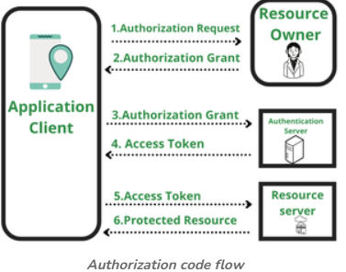
Unit Testing: Unit testing is the process where you test the smallest functional unit of code. Testing class, methods etc.
Mockito: Java mocking framework frequently used in unit testing. It enables the creation of mock objects, which simulate the behavior of real dependencies, allowing developers to isolate and test individual components of a Spring Boot application.
Steps to use Mockito:
- Create Test Class: Create a test class for the component you want to test.
- Annotate with @ExtendWith(MockitoExtension.class): This annotation initializes Mockito for the test class.
- Annotate the methods with @Test
- Use Mockito Annotations: Use @Mock, @InjectMocks, or @Spy to create mock objects and inject them into the component under test.
- Define Mock Behaviors: Use Mockito.when() to define the behavior of mock objects.
- Write Assertions: Use assertions to verify the expected outcomes of the test.
- Run Tests: Run the tests using your IDE or build tool.
@Test: Indicates that the method or class is a test block, and the code inside it is run to test the code
@Mock: Creates a mock object to stub method calls.
@InjectMocks: Injects @Mock dependencies into the class being tested.
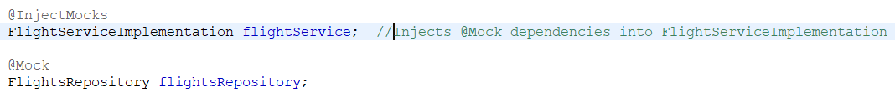
@Spy: Partially mocks an object while allowing real method calls.
@MockBean: Replaces a Spring bean with a mock for testing in the application context.
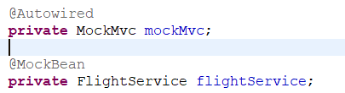
@MockMvc: Provides a way to test controllers without starting a real web server. Used to send HTTP requests in unit tests. Works with MockMvcBuilders for standalone controller testing.
@WebMvcTest: Class level annotation that loads only controller-related beans, making tests lighter and faster. Mocks dependencies like services using @MockBean.Best for testing controller logic in isolation.
Mock private methods: Use Java reflection
Mock void methods: Use donothing() and verify
Mock exceptions: Use assertThrows()
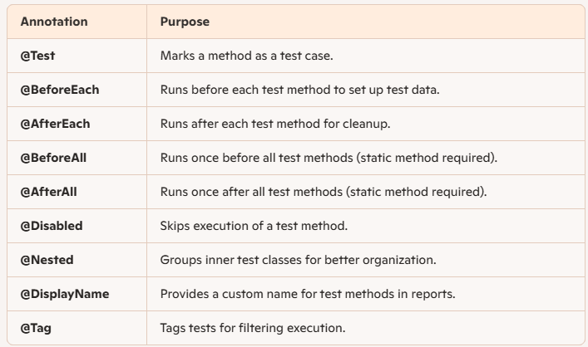
Limitations of Mockito:
- Cannot mock private, static and final methods.(Use Powermock to resolve this)
- Cannot mock constructors , equals and hashcode.
- Needs JDK 6+ and issue with multithreading
Microservices: Microservices is an architectural style where an application is built as a collection of small, independent services that communicate over lightweight protocols like HTTP or messaging queues.
Advantages: Scalable, Independent, Easier Maintenance, Faster Deployment, Fault Tolerance and Security
Disadvantages: Complex, Data Management Challenges (Single DB per service), Debugging and Monitoring and Inter communication
Spring Auditing: It involves tracking changes to data, monitoring user actions, and maintaining a historical record of these activities.

